PHÒNG GD & ĐT QUẬN LONG BIÊN ĐỀTHI HỌC KỲ I
Trường THSC Bồ Đề Môn: Tiếng Anh 6
Date: / / 2016
Name:...........................................
Class: 6A…
Mark | Teacher’s remarks
I. Listen and choose the best answer (1pt)
1.What’s the matter with Jill? 2. Which child is Ben?
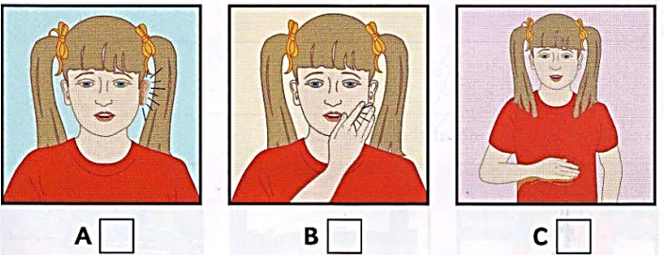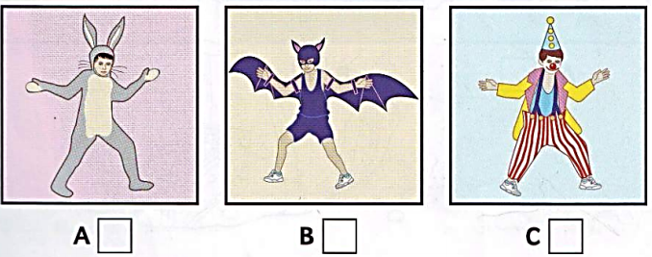
3. What does John want for lunch? 4. What does Jane want to take to Jim’ house?
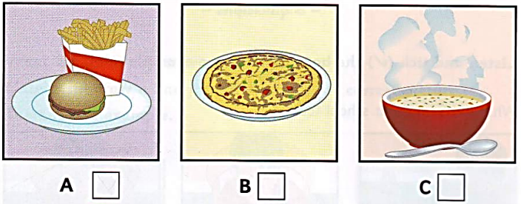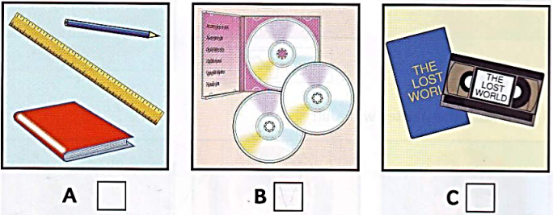
II. Read the passage and choose the best answer (1pt)
School of the Air
Many of us may be surprised to hear the name “School of the air”, but there are over ten of them in Australia. Alice Springs School of the Air is one of these in the Northern Austraila. The school provides an educational services for about 120 children living in Central Australia.
Students of this school live far from each other so they don't have normal lessons in classrooms, but they study at their homes. They get lessons from their teachers through post or e-mail. They have to work five or six hours a day, five days a week. They send their work to the teachers and discuss it over the Internet. They can borrow books from the school library, and the books arrive by post. They also take part in outside classroom activities such as sports and games.
5. Alice Springs School of the Air teaches children in…………………..
A. Central Australia B. Northern Australia C. all Australia D. Southern Australia
6. Students get their lessons from their teachers…………………
A. through post or e-mail B. through TV network C. in classrooms D. A&B
7. How many days do students have to work?
A. 4 B. 5 C. 6 D. 7
8. Students take part in ………………….. activities such as sports and games.
A. inside B. indoor C. outdoor D. classroom
III. Put the verbs into the correct form (1pt)
9. My father often (drive)……………… to work, but today he (take) …………………….the bus.
10. The Earth (move)…………………………………………………………..……around the Sun.
11. Listen! The bird (sing)………………………………..……………….………………………….
12. I (not like) ……………………………………….…………….……playing football very much.
IV. Choose the correct answers (2pts)
13. We’re lost. Can you give me the …………….?
A. compass B. sun cream C. plaster D. walking boots
14.Students….....................copy and cheat on a test.
A. shouldn’t B. should C. must D. mustn’t
15. What is Tom like? –……………………….
A. He likes football B. He doesn’t like football
C. He has blue eyes. D. He is friendly and helpful.
16.……………... was you born?
A. How B. Why C. What D. When
17.There ………………..some water in the glass.
A. is B. are C. have D. has
18.My mother doesn’t like milk…………..she usually has some milk in her coffee.
A. and B. so C. because D. but
19. Which word has the different underline sound?
A. gather B. great C. glass D. generous
20.Which word has the different underline sound?
A. cook B. clean C. celebrate D. candy
V. Fill in the blank with a suitable given word (1pt)
visit lucky pagoda decorate good
Tet is a special occasion of every country in the world. People often clean the furniture, (21)…………..….. the house and do a lot of shopping before Tet. Everyone, especially children, is happy to welcome a new year. During Tet, people usually (22)…………..……. their relative, give (23)…………. money, go to a (24)…………….. and wish others good things in life. Tet is a great time for all family gatherings. They can have traditional meal together and share what they have done in a year.
VI. Rewrite the sentences without changing the meaning (1pt)
25. Please tell me something about you.
=> Can……………………………………………………………………..……………………?
26. She has long black hair.
=> Her…………………………………………………………………………….………………
27. Travelling by airplane is more expensive than by train.
=> Travelling by train……………………………………………………………….………..
28. No one in the class is more hard-working than Jane.
=> Jane is………………………………………………………………………………..………..
VII. Re-arrange to make correct sentences. (1pt)
29. there/ Is/ a/ bank/ here?/ near
=> ………………………………………………………………………………………………...
30. What time/ you/do/bed?/ go to
=>…………………………………………………………………………………………………
31. the/You/ follow/ must/ rules.
=> ……………………………………………………………………………………………..…..
32. Tet/ a time/ is/ family gatherings./ for
=> ……………………………………………………………………………………………..…..
------------------------THE END-----------------------

ĐÁP ÁN
I. Listen and choose the best answer (1pt)
Mỗi câu đúng 0.25 đ
1. A 2. C 3. B 4. C
* Tapescript:

1. What’s the matter with Jill?
- What would you like to eat, Jill?
- I am not hungry, Mom. I don’t want any breakfast.
- What’s the matter? Have you got stomach ache?
- No, but I’ve got earache, and I am hot.
- Well, you mustn’t go outside today.
2. Which child is Ben?
- Look at the photo of my birthday party. Can you find me?
- Oh, Ben. That’s difficult. You are all wearing party clothes. Are you a bat?
- No, that’s my friend, John.
- Are you the clown then?
- Yes, I am. And my sister is a rabbit.
3. What does John want for lunch?
- Would you like some soup for lunch, John?
- We had it yesterday. Can we have something different please?
- What about a pizza?
- Oh, great! And can we have burgers and French fries for supper?
4. What does Jane want to take to Jim’ house?
- Do you want to come to my house after school, Jane?
- Yes, buy I must do my homework first. I can bring my new video. It is great!
- Oh, good! We can watch that and then listen to my new CDs.
- Ok, Jim.
II. Read the passage and choose the best answer (1pt)
Mỗi câu đúng 0.25đ
5. B 6. A 7. B 8. C
III. Put the verbs into the correct form (1pt)
Mỗi câu đúng 0.25đ
9. drives/is taking 10. moves 11. is singing 12. don’t like
IV. Choose the correct answers (2pts)
Mỗi câu đúng 0.25đ
13. A 14. A/D15. D 16. D17. A 18. D
19. D 20. C
V. Fill in the blank with a suitable given word (1pt)
Mỗi câu đúng 0.25đ
21. decorate 22. visit 23. lucky 24. pagoda
VI. Rewrite the sentences without changing the meaning (1pt)
Mỗi câu đúng 0.25đ
25. Can you tell me something about you?
26. Her hair is long and black.
27. Travelling by train is cheaper than by airplane.
28. Jane is the most hard-working student in class.
VII. Re-arrange to make correct sentences. (1pt)
Mỗi câu đúng 0.25đ
29. Is there a bank near here?
30.What time do you go to bed?
31. You must follow the rules.
32. Tet is a time for family gatherings.
-- -o0o- --
BGH duyệt Nhóm trưởng Người ra đề

Phòng GD & ĐT quận Long Biên
MA TRẬN ĐỀ THI HỌC KỲ I
MÔN: TIẾNG ANH LỚP
NĂM HỌC 2016 - 2017

Trường THSC Bồ Đề
-------o0o-------
I. Aims:
- Check the knowledge (from unit 1 to unit 6) which students have learned in the class.
- Help students realize the mistakes so that they can improv their marks next time.
II. Language Focus:
- Must/ Mustn’t/ Should/ Shouldn’t
- Comparison: Comparative and Superlative
- And/But/So
- Verb Be and Have for descriptions
- Prepositions of place
- Classroom expressions
- Present Simple/ Present Continuous

III. Objectives:

- Listen and choose the best answer.
- Which word is pronounced differently?
- Read the passage and choose the best answer
- Put the verbs into the correct form
- Choose the correct answers
- Fill in the blank with a suitable given word
- Rewrite the sentences without changing the meaning
- Re-arrange to make correct sentences

Content topic | Thinking level
Objectives to be tested | Recall/ Recognition | Comprehension/  Understanding | Application
Listening |  | 4 x 0.25p
Pronunciation | 2 x 0.25p
Reading | 4 x 0.25p | 4 x 0.25p
Writing | 4 x 0.25p |  | 4 x 0.25p
Vocabulary & Grammar | 4 x 0.25p | 4 x 0.25p | 2 x 0.25p
Speaking
Total number of questions | 14 | 12 | 6
Total of mark | 3.5pts | 3.0 pts | 1.5pts

